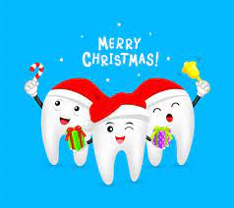
CHRISTMAS OPENING HOURS
24th December EMERGENCIES ONLY- PLEASE CALL FIRST THING IF SAME DAY APPT REQUIRED
25TH – 26TH DECEMBER CLOSED
29th – 31st DECEMBER-EMERGENCIES ONLY
1ST JANUARY CLOSED
REOPEN ON 5TH JANUARY 9AM – 5PM

ONLY EMERGENCY APPOINTMENTS WILL BE BOOKED, NO ROUTINE APPOINTMENTS. All appointments are first come first served so please call as early as possible to increase your chances of getting a same day emergency appointment if required.

In an emergency, please call 01952 825555 and leave a message with your NAME, DATE OF BIRTH, and DENTAL PROBLEM. We will contact you to arrange an appointment ASAP, please be patient as this may take longer during busy times.
IF YOU HAVE AN OUT OF HOURS EMERGENCY FROM THE 25TH DECEMBER ONWARDS PLEASE CALL NHS 111.

THE HAPPY SMILES TEAM WOULD LIKE TO WISH ALL OUR PATIENTS
A VERY MERRY CHRISTMAS AND A HAPPY NEW YEAR


